Ideation Phase

Brainstorm & Idea Prioritization Template

|  |  |
| --- | --- |
| Date | 19 September 2022 |
| Team ID | NM2023TMID08418 |
| Project Name | Analytics Tool For Placements |
| Maximum Marks | 4 Marks |

# Brainstorm & Idea Prioritization Template:

Brainstorming provides a free and open environment in order to develop and prioritize ideas for the Analytics Tool for Placements, it is essential to first conduct a brainstorming session involving all stakeholders. During this session, a wide range of ideas can be generated, such as improving data collection, implementing advanced data analytics techniques, enhancing visualization features, and strengthening alumni engagement. Once these ideas are collected, they can be prioritized based on their potential impact on the project's objectives and the resources available. For instance, data security and integration might take precedence to ensure data reliability, while predictive modeling could be a priority to anticipate placement trends.

Reference: <https://www.mural.co/templates/empathy-map-canvas>

# Step-1: Team Gathering, Collaboration and Select the Problem Statement

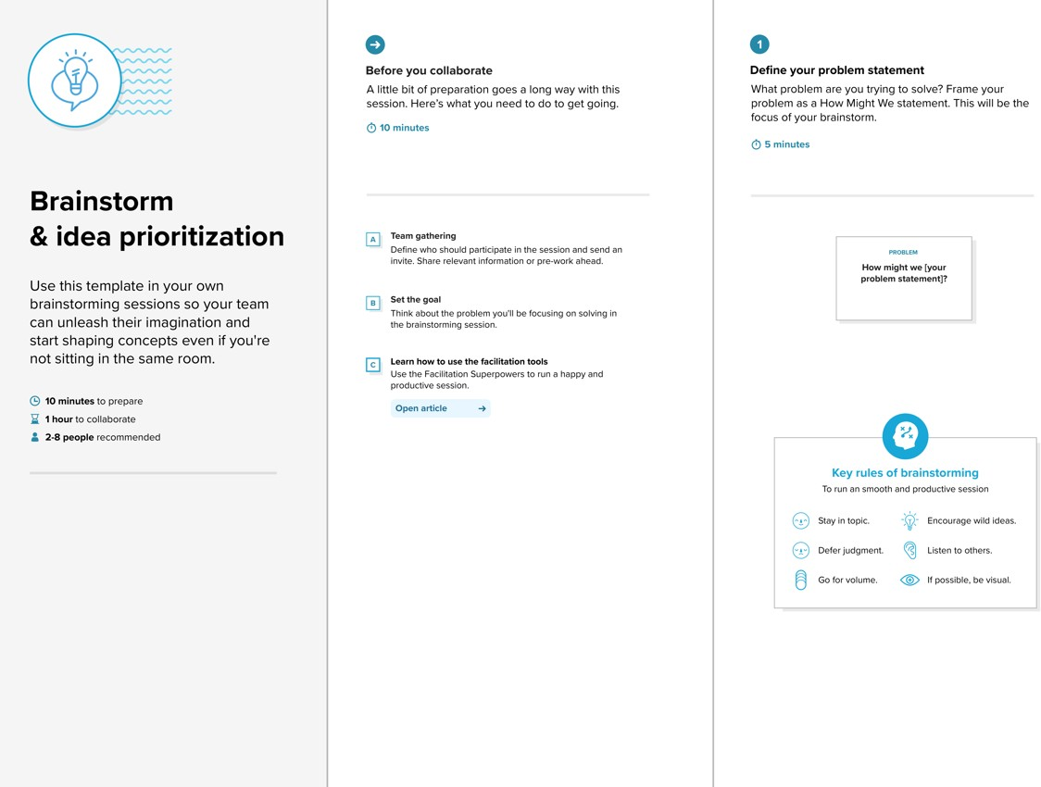

**Step-2: Brainstorm, Idea Listing and Grouping**

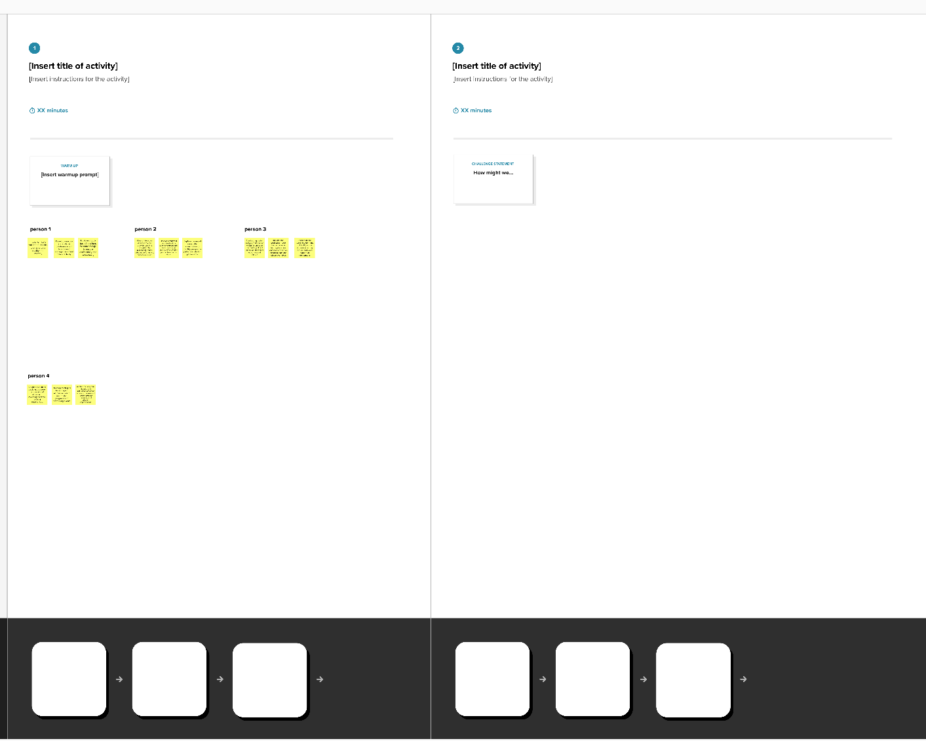

**Step-3: Idea Prioritization**

